Contents

Preface 2

Var variable type of java. 3

Usage 3

Var is not backward compatible 3

Var does not impact performance 4

Unmodifiable Collections 4

List.copyList( Collection ) 4

toUnmodifiable() 4

Optional new method orElseThrow() 5

Time-Based Release of Verions java 5

Reference 6

# Preface

Java 10 was introduced 20/03/2018

Var variable is added

Unmodifiable Collections

Optional new method orElseThrow()

Time-Based Release of Verions java

# Var variable type of java.

Java has been progressively working on reducing the verbosity from syntax. It was Diamond operator (<> Generic), and now it is var to declare variables in java. When you are using Var to declare basically, instead of declaring a variable type, it assumes its type from what it is being set.

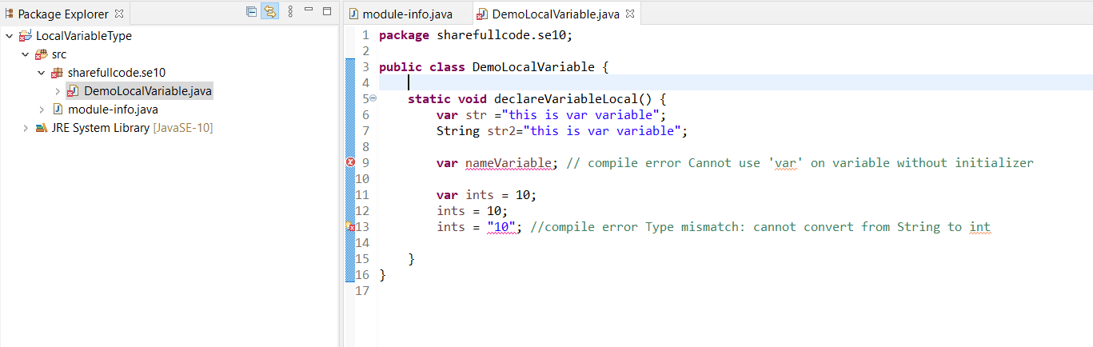

## Usage

Using var for to local variables with initializers, indexes in the enhanced for loop. It would not be available for method formals, constructor formals, method return types, fields, catch formals, or any other kind of variable declaration.

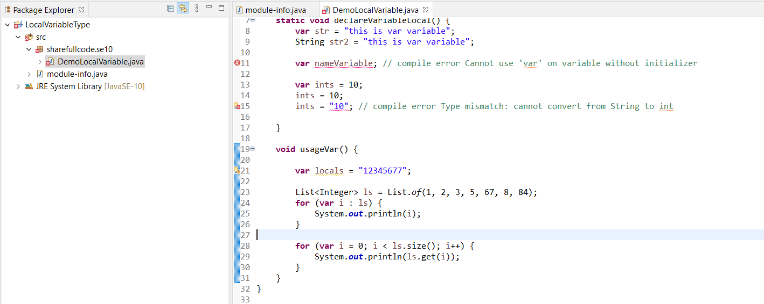

## Var is not backward compatible

As this is new language feature, code written using var will not be complied in lower JDK versions 10. So use this feature only when you are sure about it.

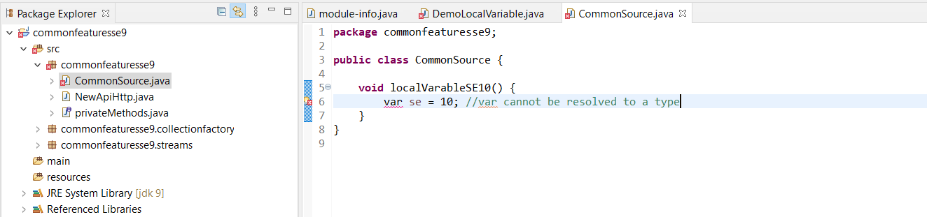

## Var does not impact performance

Remember, in Java the types are not inferred at Runtime, but at compile time. That means the resulting bytecode is the same as with explicit type declaration it does include the information about the type.

# Unmodifiable Collections

## List.copyList( Collection )

List, Map, Set each got a new static method copyOf(Collection). It returns the unmodifiable copy of the given Collection.

List<String> copyList = List.copyList (CollectionList);

Copylist.addAll(list_other);

Throw exception UnsupportedException.

## toUnmodifiable()

it return a Collection not change

List<Integer> listUnmodifiable = Stream.of(2,3,5,76,2,2,45,3,2).collect ( Collectors.toUnmodifiable() );

listUnmodifiable.addAll(list_other);

Throw exception UnsupportedException.

# Optional new method orElseThrow()

Optional, OptionalDouble, OptionalInt, OptionalLong each got a new method orElseThrow which dosen’t take any argument and throws NoSuchElementException

List.Stream().Filter (true).findFirst().orElseThrow()

It the preferred alternative to the use get() method.

# Time-Based Release of Verions java

Start with java 10, Oracle has moved to the time-based released of java. This has following implications:

A new java release every six months.

Long-team support release will be marked as LTS, support for three years

Java 11 will be an LTS release.

# Reference

This section is non commercial mainly sharing and advance knowlage for java.This tutorials has referenced document from the list below if you has complain for license, i will remove all from internet. Thank you all everything

<https://howtodoinjava.com/java10/var-local-variable-type-inference/>

<https://www.baeldung.com/java-10-overview>